Report on UI issues

* Satvik Shrivastava

Hello, I found few UI issues in the OpenMRS

Ref Application. I have listed them all here.

A next button:

(Home> register a patient)

The current Registration panel doesn’t have a next button in the form. For proceeding further, ‘enter’ on keyboard and ‘tab’ on mobile devices is hit. An alternate option would be a next button which the user can use to proceed further. Also, while choosing the gender, it creates problem, especially in tablets and phones. [fig.1]

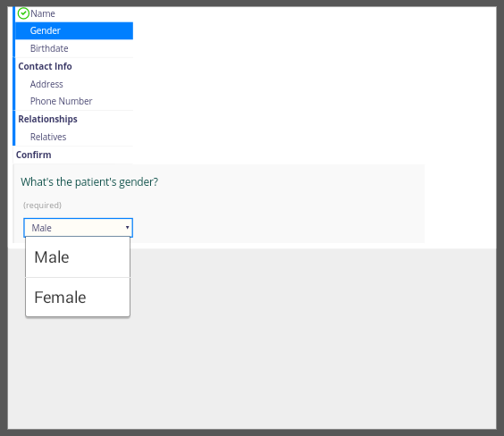

**[Fig. 1]**

Here’s a design I prepared to overcome this issue:

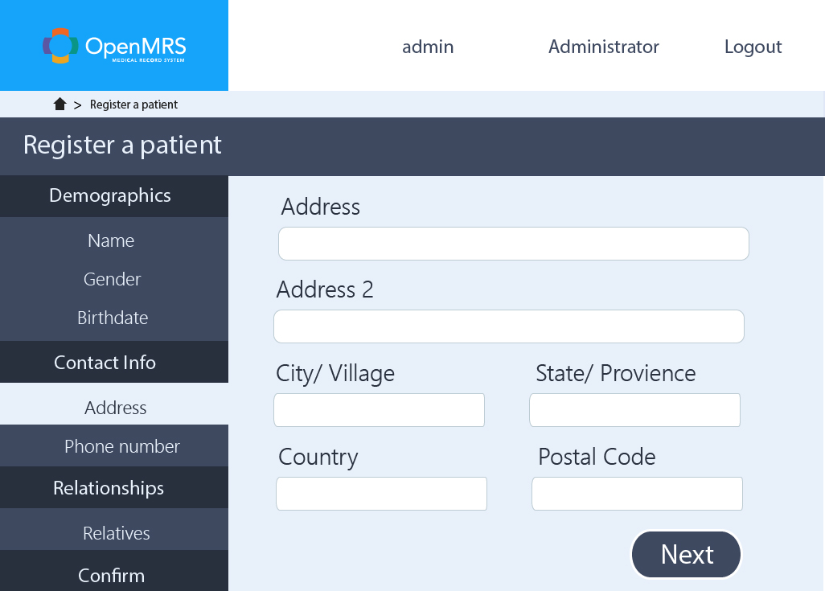

I added a ‘next’ button and modified the UI to make it more clear, big and systematic for the user.

Time zone conversion:

(Home> appointment scheduling> appointment request)

The current request panel requires the time zone of local instance to be set in UTC. Many users would want to register according to their local Time, to avoid any confusion. A simple conversion from their Local Time to UTC will help.

Current:

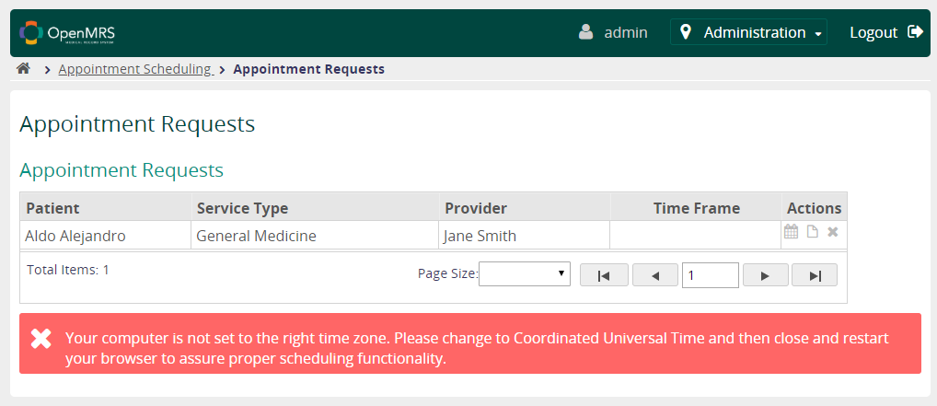

**Proposed:**

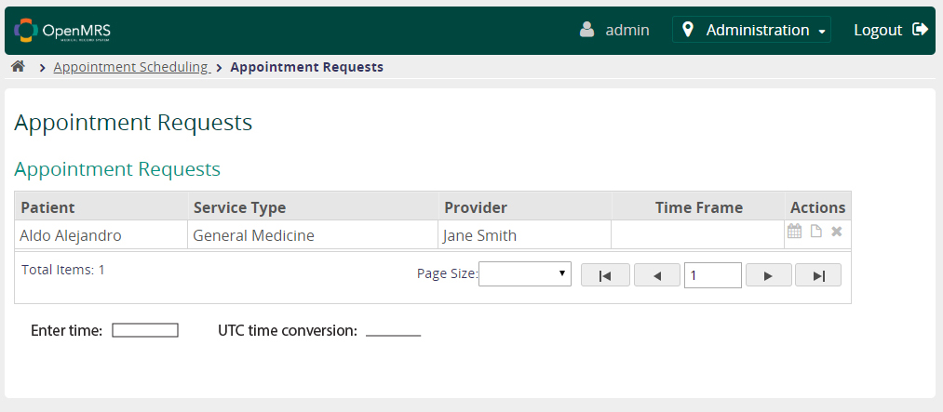

List complete patient Data:

(Home> find a patient record)

Currently, hitting blank enter results in no output. I think hitting blank enter should show list of all patients’ records. It will also be useful for searching unidentified patient’s records whose ID might have been lost.

Also, there should be a filter to sort the results according to their date or according to the alphabetical order. This would help us narrow down the results.

Proposal:

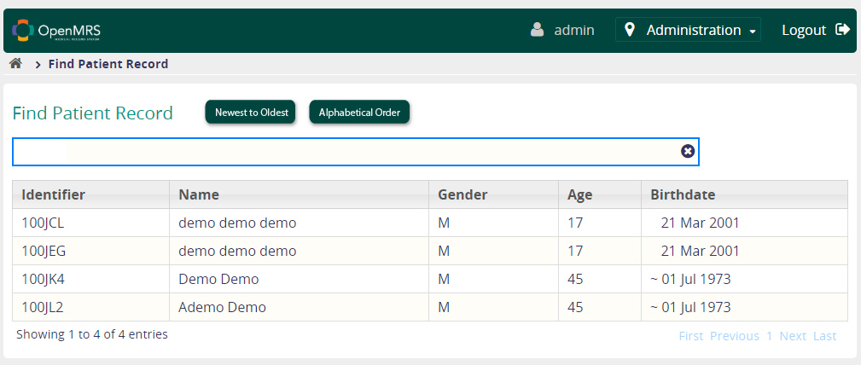

Thank you!